Adapted web article from Gizmag by Ben Coxworth 21 January 2014
Sugar batteries could be greener, cheaper, and store more energy than lithium ion batteries


Even the best rechargeable lithium-ion batteries lose their ability to hold charge after a while. They are considered as toxic waste when you throw them away.
But in just a few years, lithium batteries might be replaced by batteries that are refillable and biodegradable, and that will also have a higher energy density (large amount of stored energy for its mass) yet a lower price. The new batteries will run on sugar.
“Sugar is a perfect energy storage compound in nature,” says Percival Zhang,
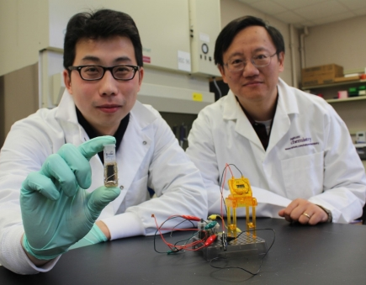
Percival Zhang is leading the research in Virginia Tech, USA. “It is only logical that we try to harness this natural power in an environmentally friendly way to make a battery.”
The new battery is actually a fuel cell. It uses a sugar called maltodextrin, which is made from starch. Natural compounds called enzymes help maltodextrin to break down in the presence of air. This generates electricity.
Zhiguang Zhu (left) and T.H. Percival Zhang of Virginia Tech with their new sugar battery.
Zhang says that people will be able to refill the batteries with sugar when they need refuelling. He hopes that they may be powering electronic devices in as little as three years.
A paper on the research was published today in the scientific journal Nature Communications.

